Question 1 (7 marks)
(a) Part of the graph of is shown below.

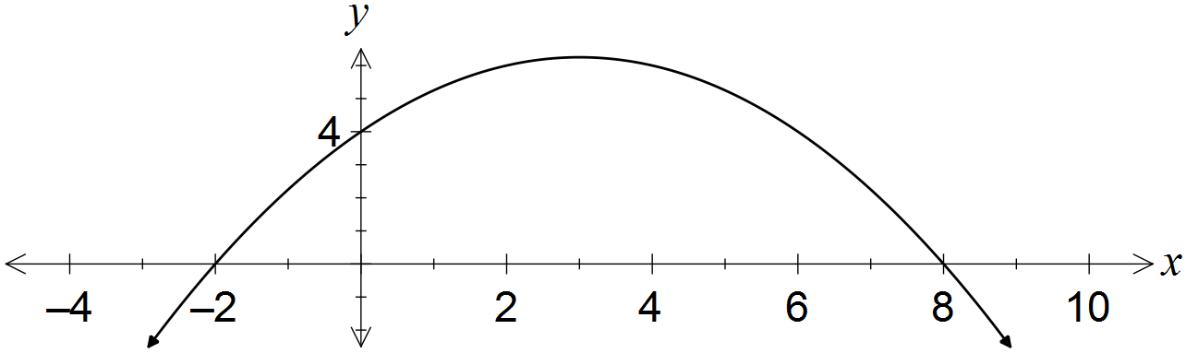

Determine the values of the coefficients a and b. (3 marks)
Solution
Specific behaviours
uses roots to express in factored form
uses y-intercept to find a
expands and states b

(b) A quadratic has equation . Determine

(i) the coordinates of its turning point. (2 marks)
Solution
Specific behaviours
completes square, or uses x=-b/2a
states coordinates

(ii) the exact values of the zeros of the quadratic. (2 marks)
Solution
Specific behaviours
uses quadratic formula or completes square
states both roots in exact form

(c) Is it possible to bend a 12 cm length of wire to form the perpendicular sides of a right angled triangle with area 20cm? (4 marks)

Solution
Height = x , Base = 12-x

Area: $20$ $=\frac{1}{2}x(12-x)$
$$40=\frac{1}{2}x\left(12-x\right)$$
$$12x-x^{2}-40=0$$
$$x^{2}-12x+40=0$$

Discriminant = ${\left(-12\right)}^{2}-4\left(1\right)\left(40\right)$
$= -16 which is <0$
There are no real solutions, indicating this situation is impossible.
Specific behaviours
Use of $x$ and $12-x$ correctly.
Substituting into area of a triangle formula
Correct general formula
Use of discriminant to indicate no real solutions.

Note: 1 mark if they indicate that they would need two numbers which add to 12 and multiply to 40, 1 mark if they try some values to show that it is not possible, 1 mark if they set out a table in an orderly manner and reach the maximum of 6x6 giving 36 (ie max area is 18sq m) and 1 mark for demonstrating that this is the maximum by extending the table etc. Basically use your professional judgement and (generously) allocate a mark out of 4 accordingly.

Question 2 (8 marks)
(a) A circle of radius 5 has its centre at (6, -4).

(i) Determine the equation of this circle. (2 marks)
Solution
Specific behaviours
uses standard circle form with correct radius
correct equation

(ii) State, with justification, whether the point (9, -8) lies on the circle. (1 mark)
Solution
Specific behaviours
substitutes point into equation from (a) and interprets

(b) Determine the centre and radius of the circle with equation .
(3 marks)
Solution
Hence centre at (2, -3) and radius 2
Specific behaviours
factors x terms
factors y terms
states centre and radius

(c) Find the equation of the curve drawn below. (3 marks)
Solution
$$y=k\sqrt{x+b}+c$$
$$y=2\sqrt{x+3}-2$$
Specific behaviours
$a=3$
$k=2$
$c=-2$

Question 3 (1.1.14) (2, 2, 2 = 6 marks)
A rectangular hyperbola has asymptotes with equation $x=-2$ and $y=4$.
- Write two possible equations for this function

Solution
$y=\frac{a}{x+2}+4$ so a could be any number eg $y=\frac{1}{x+2}+4$ and $y=\frac{-1}{x+2}+4$

Specific behaviours
two possible equations

- Write the equation of this function if it has a y-intercept at (0,5)

Solution
$5=\frac{a}{0+2}+4$ so a=2

Specific behaviours
substitutes correctly into equation
a=2

- Write the equation of this function if it passes through the point (3,5)

Solution
$5=\frac{a}{3+2}+4$ so a=5 therefore y$=\frac{5}{x+2}+4$

Specific behaviours
substitutes correctly into equation
states equation

Question 4 (1.1.24) (1, 2, 1, 2 = 6 marks)
- Given $f\left(x\right)=x^{2}-2x$

- What type of correspondence does $f$ show? Circle one of the following.

Many-to-one One-to-many One-to-one

Specific behaviours
Many to one

- If the domain of $f$is $f\left(x\right)∈R, -4≤x≤5$, find the range of $f.$

Specific behaviours
$-1≤y≤$ 24

- Given $y=2+\sqrt{4-x^{2}}$

- What is the largest possible value of $y$.

Specific behaviours
$y=$ 4

- Determine the domain and range.

Specific behaviours
$-2≤x≤$ $2$
$2≤y≤$ $4$

Question 5 (1.1.24) (1, 1, 2, 2 = 6 marks)
Suppose $G\left(x\right)=\frac{2x-3}{x-4}$.

- Evaluate $G\left(2\right)$

Solution
$-\frac{1}{2}$

- Find a value of x such that $G\left(x\right)$ does not exist.

Solution
$x=4$

- Find $G(x+2)$ in simplest form.

Solution
$$g\left(x+2\right)=(2\left(x+2\right)-3)/(\left(x+2\right)-4$$

$$g\left(x+2\right)=\frac{2x+1}{x-2}$$

Specific behaviours
Substitute correctly
Answer

- Find x such that $G\left(x\right)= -3.$
Solution
$$-3=\frac{2x-3}{x-4}$$
$$x=3$$

Specific behaviours
Sets equation up correctly
Answer

